CHAPTER 20: MULTITHREADING AND MULTITASKING **🖥️🧵**

In this chapter, we will break down how Windows handles **multitasking** and **multithreading**, with simple explanations, key concepts, and practical examples. We’ll also include insights from Charles Petzold's book to give context.

1. Multitasking **⏱️**

**Multitasking** is the ability of the operating system to run multiple programs at the same time.

* Windows does this by giving each program a **time slice**.
* Programs appear to run simultaneously, even if the CPU is only executing one instruction at a time.
* This improves **system responsiveness** and lets you switch between apps seamlessly.

**Evolution in Windows:**

* **16-bit Windows:** Used **cooperative multitasking**. Programs had to voluntarily give up CPU control. If one program “hung,” the whole system could freeze.
* **32-bit Windows:** Introduced **preemptive multitasking**. The OS actively manages CPU time, making sure no program monopolizes it.

2. Multithreading **🧵**

**Multithreading** is when a single program splits into multiple **threads**, which are lightweight units of execution within the program.

**Benefits of multithreading:**

* Run **background tasks** without freezing the interface.
* Keep **UI responsive** while other operations run.
* Execute **independent tasks in parallel**, improving performance on multiprocessor systems.

3. Key Terminology **📚**

* **Process:** A running program with its own memory and resources.
* **Thread:** A smaller execution unit inside a process. Threads share memory and resources with their parent process.
* **Context Switching:** Saving and restoring a thread’s state when switching to another thread.
* **Synchronization:** Methods to safely coordinate access to shared resources between threads, avoiding **race conditions** or data corruption.

4. Topics Covered in Chapter 20 **✅**

**Thread Creation and Management**

* Use CreateThread to start a new thread.
* Threads can have **priorities** set, and you can **suspend**, **resume**, or **terminate** them.

**Synchronization Techniques**

* Prevent conflicts when threads access shared data using:
  + **Critical Sections** – fast, process-local locks.
  + **Mutexes** – system-wide locks.
  + **Semaphores** – control access to a resource with limited availability.
  + **Events** – signal between threads.

**Thread-Specific Storage**

* Use TlsAlloc, TlsGetValue, and TlsSetValue to give each thread its own private data.
* Useful when multiple threads need independent copies of the same type of data.

**Win32 Timers**

* SetTimer and KillTimer schedule recurring or one-time events.
* Timers are handy for repeating tasks without blocking the main thread.

**Asynchronous Procedure Calls (APC)**

* Execute code asynchronously in a separate thread using:
  + BeginThreadEx – create a thread safely in Windows.
  + QueueUserAPC – queue code to run in a specific thread.

5. Best Practices in Multithreading

* Avoid **deadlocks** by careful locking order.
* Optimize **thread performance** by limiting unnecessary threads.
* Ensure **thread safety** when multiple threads access shared resources.

MULTITASKING IN THE DOS ERA

Before Windows made multitasking smooth, DOS had **ideas** but a lot of **practical limits**.

* Users **wanted multitasking** (running multiple programs at once).
* DOS **wasn’t built for it** — hardware and software got in the way.
* Early attempts were **creative but limited**.

Why DOS Struggled

I. Hardware Limits

* CPUs like the **Intel 8088** had **no memory management unit (MMU)**.
* Programs had to share **one flat memory space**, making juggling apps tricky.
* Moving memory blocks to free up space was slow and hard.

II. DOS Architecture

* DOS was **simple and lean** — designed for **single-tasking**.
* APIs were basic: mostly **file access** and **program loading**.
* No robust system services → developers couldn’t easily implement multitasking.

Think of DOS as a **tiny studio apartment**:

* Only one person (program) can comfortably live there at a time.
* You *could* squeeze in another, but furniture (memory) had to be constantly moved.
* Windows later gave everyone **their own rooms (protected memory & system services)** — suddenly multitasking made sense.

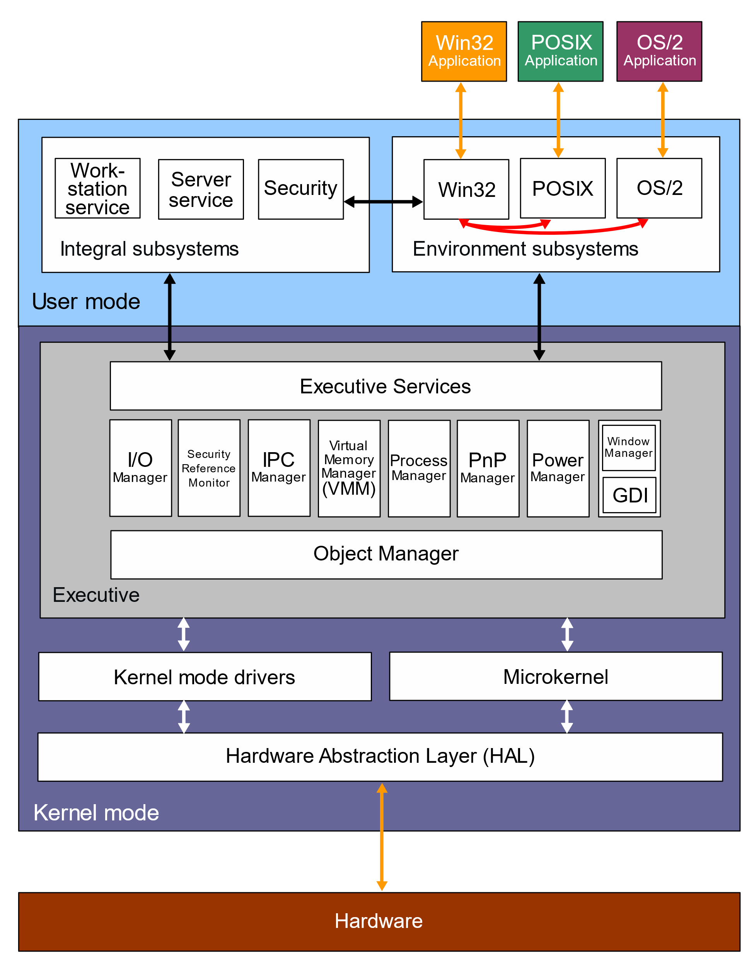

Creative Workarounds & Multitasking in DOS **🖥️✨**

Even though DOS wasn’t designed for multitasking, **clever programmers found ways to simulate it**.

1. TSR Programs (Terminate-and-Stay-Resident)

* TSRs stayed **in memory** after their main program closed, running in the background.
* Examples:
  + **Print spoolers:** used the hardware timer interrupt to print while you worked on another program.
  + **Borland SideKick:** temporarily paused your current app to show its interface, then returned control.
* TSRs were **early multitasking hacks**, letting small tools coexist with other programs.

2. Enhanced DOS Features

* Microsoft added **memory swapping to disk** and other tweaks.
* These **helped manage memory** better, indirectly supporting background activities.

3. Market Experiments

* **Task-switching shells** like **Quarterdeck DesqView** allowed running multiple DOS programs.
* Reality check: performance was slow, setup was tricky, adoption was limited.

4. Key Takeaways

* Multitasking was **desired by users**, even on single-user PCs.
* Programmers used **TSRs and simple task-switchers** to stretch DOS’s limits.
* These efforts **highlighted the need for OS-level multitasking**, eventually realized in Windows.

5. Exploration Ideas

* Study **popular TSRs**: what they did, how they worked.
* Dive into **DOS memory management** and **context switching** challenges.
* Compare DOS multitasking hacks vs. **Windows 3.x and later**, seeing how true multitasking became practical.

💡 Mental shortcut: DOS multitasking = **hacks in a single-room apartment**.

* TSRs = roommates who quietly exist in the background.
* Task-switchers = rotating chairs; clunky but functional.
* Windows = actual multiple rooms, each app gets space, fully coordinated.

Multitasking in Early Windows **⚡**

Early Windows (1.0, 1985) **brought multitasking out of DOS limitations**, giving multiple programs a graphical workspace and basic coordination.

1. Windows 1.0’s Multitasking Breakthrough

* **Graphical interface:** Multiple programs could run concurrently, unlike DOS command-line shells.
* **Cooperative multitasking (nonpreemptive):**
  + Programs only yield control voluntarily after processing messages.
  + Relies on well-behaved programs; a stuck program could freeze the system.
* **Message-based architecture:** Programs are idle until a message arrives.

**Workarounds & Limitations**

* **Preemption:** Used only for DOS programs or certain multimedia tasks (DLLs needing hardware timing).
* **Hourglass cursor:** Visual cue for busy programs.
* **Windows timer & PeekMessage:** Let programs periodically handle messages, preventing total freeze during long tasks.

2. Data Sharing Mechanisms

**a) Clipboard**

* **Basic & versatile:** For cut/copy/paste across applications.
* **Temporary storage:** Holds data for short-term transfer.
* **Manual operation:** User-controlled, not automatic.

**b) Dynamic Data Exchange (DDE)**

* **Live links:** Programs exchange data in real-time, even if idle.
* **Client-server model:** One app requests updates from another.
* **Examples:** Stock tickers, spreadsheets linked to databases.
* **Caveats:** Complex, fragile if connections fail.

**c) Object Linking and Embedding (OLE)**

* **Embedding objects:** One document can contain content from another program.
* **In-place editing:** Edit objects directly within the main document.
* **Example:** Edit a spreadsheet chart inside Word without launching Excel.
* **Use case:** Rich, interactive compound documents.

3. Key Points

* Clipboard → simple, manual data sharing.
* DDE → live updates between programs, more complex.
* OLE → seamless object integration for richer documents.
* 16-bit Windows used **cooperative multitasking**, with no enforced preemption.
* System responsiveness relied on programs yielding control voluntarily.

4. Further Exploration

* Investigate challenges of **preemptive multitasking** in 16-bit Windows.
* Study real examples of **application freezes or bottlenecks** under cooperative multitasking.
* Track the evolution toward **preemptive multitasking** in 32-bit Windows.
* Modern parallels: **Clipboard history, cloud sync**, **XML/JSON** for universal data exchange, and **OLE alternatives** like ActiveX or .NET components.

💡 Mental shortcut:

* DOS multitasking = roommates squeezing in one apartment.
* Windows 1.0 = a shared living room where everyone must **take turns politely**.
* Clipboard/DDE/OLE = ways to **pass notes between roommates without chaos**.

Multithreading & The Evolution of Input

1. The History Lesson: Why OS/2 Failed

Before Windows 95/NT, Microsoft and IBM built **OS/2 Presentation Manager (PM)**. It was a 32-bit operating system with a fatal flaw in how it handled user input.

**The Flaw: The Serialized Message Queue** In OS/2, the system had *one* single pipe for all keyboard and mouse clicks for every running program.

* **The Rule:** The system would not process Input B until the application finished processing Input A.
* **The Goal:** Predictability. If you type "ABC", the system guarantees "A" is processed before "B".
* **The Reality:** If one program crashed or hung while processing "A", the entire system froze. You couldn't click on another window because the mouse click was stuck in the queue behind "A".

**The Lesson:** A robust OS cannot let one bad app freeze the whole mouse.

2. The Windows Solution: Deserialized Input

Modern Windows (Win32 API) fixed this by giving every thread its own private message queue.

* **How it works:** When you click on Chrome, Windows looks at where the mouse is, determines which thread owns that window, and drops the message directly into *that specific thread's* queue.
* **The Benefit:** If Chrome hangs, Notepad keeps working. You can Alt-Tab away from a frozen program.

3. The Architecture of a Multithreaded App

In modern Windows programming, we divide labor to keep the application responsive.

**The "Governor & Staff" Model**

1. **The Primary Thread (The Governor):**
   * **Job:** Creates windows, runs the Message Loop, handles the UI (WM_PAINT, buttons).
   * **Rule:** Never do heavy lifting here. If you calculate Pi to the billionth digit here, the UI freezes, and the window says "(Not Responding)".
2. **The Secondary Threads (The Staff):**
   * **Job:** Long calculations, file I/O, networking.
   * **Rule:** They do *not* own windows. They crunch numbers in the background and tell the Governor when they are done.

4. What Threads Share vs. What They Keep

When you create a new thread, it is not a separate program. It lives inside the same "house" (Process).

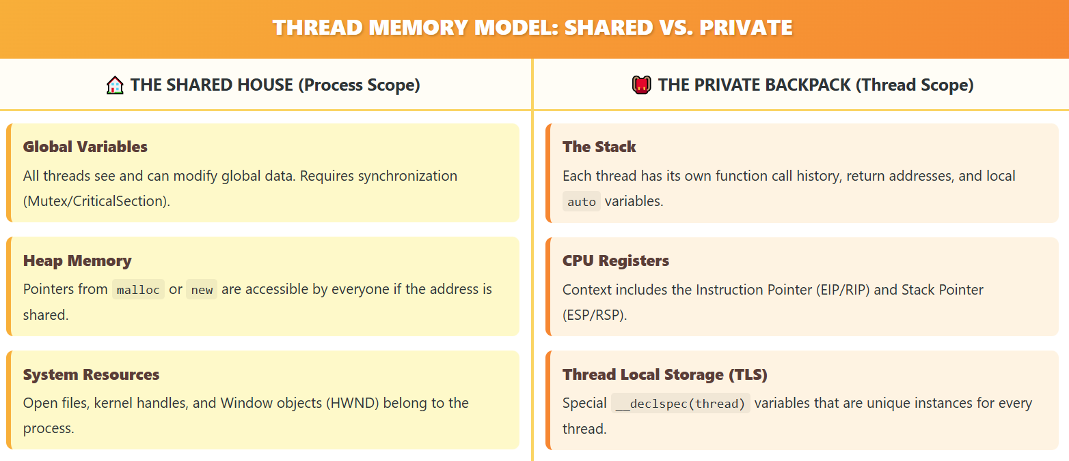

**The Danger:** Because they share global memory, two threads can try to write to the same variable at the exact same time, causing corruption (Race Conditions).

5. Summary Checklist

* **OS/2 PM** failed because one frozen app froze the whole system (Serialized Input).
* **Windows** succeeds because input is split per thread (Deserialized Input).
* **Primary Thread:** Handles UI/Messages.
* **Secondary Thread:** Handles heavy math/background work.
* **Threads share memory**, which makes them fast but dangerous (requires synchronization).

**Next Step:** Now that we know *why* we need threads, we need to look at **how to create them** using _beginthreadex vs CreateThread.

THREADING CHALLENGES & BEST PRACTICES

Multithreading is powerful, but it introduces a new class of bugs that are arguably the hardest to debug in all of computer science.

1. The Chaos: Race Conditions and Deadlocks

In a single-threaded program, you know exactly which line of code runs next. In a multithreaded program, the Operating System acts like a chaotic referee. It pauses Thread A and runs Thread B at random times—sometimes right in the middle of a calculation.

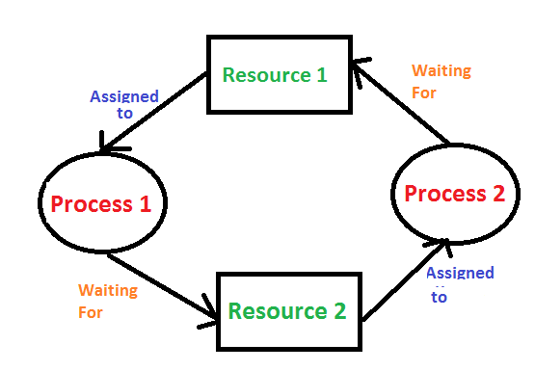

**The Race Condition** This happens when two threads try to change the same variable at the same time.

* *Thread A* reads Score = 10.
* *Thread B* reads Score = 10.
* *Thread A* adds 1 and writes 11.
* *Thread B* adds 1 and writes 11.
* *Result:* The score should be 12, but it is 11. Data is lost because they "raced" to write.

**The Deadlock** This happens when two threads stop and wait for each other.

* *Thread A* holds Key 1 and waits for Key 2.
* *Thread B* holds Key 2 and waits for Key 1.
* *Result:* They both wait forever. The program freezes.

2. The Fix: Synchronization

To stop the chaos, you need **Synchronization Primitives**. These are tools that force threads to wait their turn.

* **Critical Sections:** A block of code that only one thread can enter at a time. It is like a bathroom with a lock. If Thread A is inside, Thread B must wait outside until A leaves.
* **Semaphores:** Like a bouncer at a club. It allows a specific number of threads in at once (e.g., allowing 5 connections to a database).

3. The Hardware Reality: 16-bit vs 64-bit

**The Old Days (16-bit)** Processors were simple. Even adding 1 to a large number required two CPU cycles. If the OS interrupted the thread between cycle 1 and 2, the number would be corrupted. You had to lock everything.

**The Modern Era (64-bit)**

* **Atomicity:** Modern CPUs can read and write huge numbers (64-bit) in a single cycle. You don't need locks just to read a variable.
* **The New Danger (Optimization):** Modern CPUs are smart. They reorder your instructions to run faster. They might run Line 10 before Line 5 if they think it is safe. In multithreading, this can break your logic.
* **Takeaway:** Do not rely on hardware tricks. Always use proper Synchronization (locks) to be safe.

4. Windows Advancements

Windows evolved to make threading easier and safer.

**A. Deserialized Input (The Fix for Freezing)** - We covered this in the last section. Windows gives every thread its own input queue so a frozen background thread doesn't freeze the mouse cursor.

**B. Thread Local Storage (TLS)** Global variables are dangerous because all threads share them (leading to Race Conditions). TLS allows you to create a "Global" variable that is unique to each thread.

* If Thread A writes "Red" to *Color*, it sees "Red".
* If Thread B writes "Blue" to *Color*, it sees "Blue". They use the same variable name but look at different memory addresses.

5. The "New & Improved" Fallacy

Just because you *can* use threads doesn't mean you *should*. Threads add overhead. The CPU wastes time switching context between them.

**The 1/10 Second Rule (100 Milliseconds)** Use this rule of thumb to decide if you need a thread:

* **Task takes < 100ms:** Do not use a thread. Just run it. The user won't notice the tiny pause.
* **Task takes > 100ms:** Use a secondary thread. If you don't, the UI will freeze, and the user will think the app crashed.

6. Summary Checklist

1. **Race Conditions** happen when threads share data without locks.
2. **Deadlocks** happen when threads wait for each other.
3. **Critical Sections** prevent these bugs by forcing single-file access.
4. **TLS** gives threads private data.
5. **Only thread** if the task is slow (over 1/10th of a second).

The Two Ways to Spawn a Thread

a) The Raw Windows API (CreateThread)

This is the native function provided by the OS.

* **Pros:** It gives you granular control (Security attributes, Stack size).
* **Cons:** It does **not** set up the C Runtime (CRT).
* **The Danger:** If you use C functions like malloc, printf, or strtok inside a thread created with CreateThread, the program might crash or leak memory because the CRT data structures weren't initialized for that thread.

b) The C Runtime Helper (_beginthreadex)

This is the wrapper function provided by Microsoft's C library.

* **Pros:** It initializes the C Runtime, then calls CreateThread internally.
* **Cons:** Slightly different syntax.
* **The Rule:** Always use _beginthread (or _beginthreadex) if your thread uses any C library functions.

**Comparison Table:**

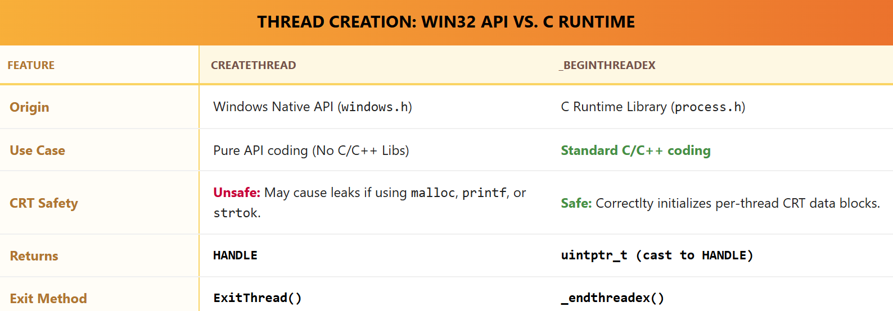

The Random Rectangles Program (RNDRCTMT.C)

This program demonstrates the simplest possible multithreaded app:

* **Thread 1 (Main):** Handles the Window (Resizing, Closing).
* **Thread 2 (Worker):** Draws random colored rectangles on the window background forever.

I. How it works:

1. **WinMain:** Registers the class and creates the window.
2. **WM_CREATE:** The main thread calls _beginthread(Thread, ...) to spawn the worker.
3. **The Worker Loop:**
   * It sits in a while(TRUE) loop.
   * It generates random x, y, color values.
   * It calls Rectangle to draw on the screen.
4. **WM_SIZE:** When you resize the window, the Main Thread updates the global variables cxClient and cyClient. The Worker Thread reads these new values instantly and starts drawing in the new area.

II. The Compiler Setting (Crucial!)

You cannot just compile this code normally. You must tell the compiler: *"I am using threads."*

* **The Switch:** /MT (Multithreaded Static) or /MD (Multithreaded DLL).
* **The Library:** It links against LIBCMT.LIB.
* **What it does:** It changes standard functions like strtok. In a single-threaded app, strtok uses a static variable to remember where it left off. In a multithreaded app, LIBCMT replaces that static variable with **Thread Local Storage (TLS)** so two threads using strtok at the same time don't corrupt each other's strings.

III. Critical Bug Warning (Synchronization)

The RNDRCTMT.C example is simple, but it has a **Hidden Race Condition**.

**The Shared Data:** cxClient and cyClient (Window Size).

**The Race:**

* Thread 1 (Main) is writing cxClient = 500.
* Thread 2 (Worker) is reading cxClient.

It is possible for Thread 2 to read the variable *while* Thread 1 is halfway through writing it (on 16-bit systems especially).

**The Fix:** Real programs need a **Critical Section** to lock the variable while reading/writing.

IV. Summary Checklist

1. Use _beginthread instead of CreateThread to keep malloc safe.
2. Enable the **Multithreaded (/MT)** setting in your compiler.
3. **Global Variables** are the easiest way for threads to talk, but they are dangerous without locks.
4. **Automatic Variables** (inside functions) are safe; every thread gets its own copy on its own stack.

THE PROGRAMMING CONTEST CHALLENGE: A DEEPER DIVE

This passage explores a fascinating programming contest from 1986, providing a glimpse into the early days of multitasking and offering valuable insights into how technology and programming practices have evolved. Here's a deeper look at the key elements:

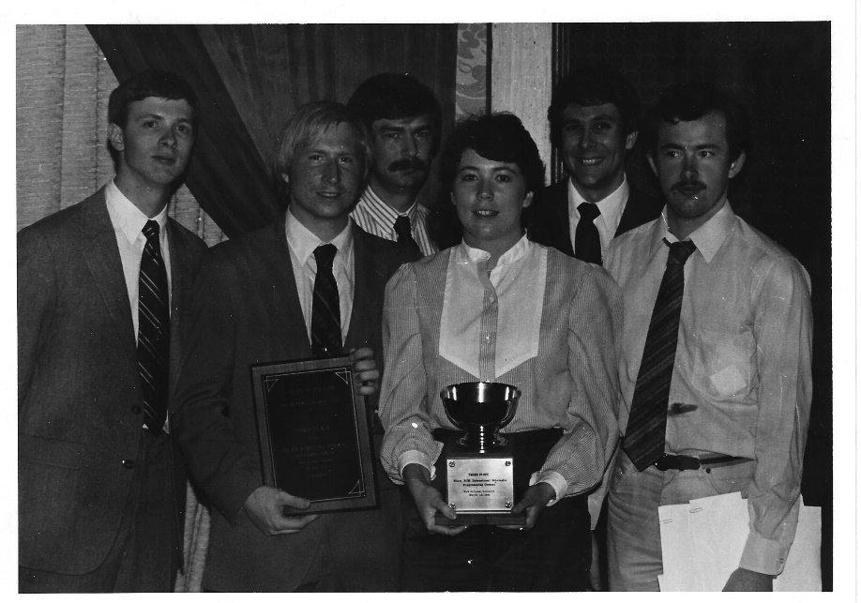

The Challenge:

Multitasking Simulation: Create a program simulating four windows displaying distinct tasks:

* Window 1: Increasing numbers (sequential)
* Window 2: Increasing prime numbers
* Window 3: Fibonacci sequence
* Window 4: Randomly sized circles

Multitasking Environment: While still a novelty in 1986, the problem demanded consideration of parallel execution and efficient resource utilization.

Time Constraint: Designed for completion within 30 minutes, it emphasized swift programming and efficient solutions.

Contestant Approaches:

DOS-based Solutions:

Screen Division: Most used a loop to sequentially update each window, emulating multitasking within a single screen.

High CPU Usage: Programs consumed 100% CPU time due to the single-threaded model.

Windows 1.0 Perspective: Though not explicitly addressed, the passage provides a hypothetical scenario of how the program might have looked adapted for the nascent Windows environment.

MULTI1 Program: The included sample code showcases a more robust solution leveraging Windows' multitasking capabilities.

Insights and Evolution:

Technological Leap: The contest highlights the significant progress made in multitasking technology since the late 1980s.

Shifting Paradigms: From single-threaded loops to true multitasking, the challenge demonstrates the evolution of programming approaches.

Abstraction and Efficiency: Modern operating systems and programming languages now provide powerful tools for efficient and elegant multitasking solutions.

Additional Aspects to Consider:

* Concurrency Mechanisms: Different approaches to implementing true multitasking in the hypothetical Windows version, such as threads or processes.
* Resource Management: Strategies for balancing CPU usage and data sharing between threads to optimize performance.
* User Interface Design: Enhancing the visual representation of the four tasks and user interaction in a Windows-based environment.

Overall, this passage offers a thought-provoking reminder of the rapid advancement in multitasking technology and programming practices. It serves as a valuable case study for understanding the challenges and potential of creating concurrent applications, making it relevant not only for historical context but also for ongoing advancements in software development.

MULTI1.C PROGRAM

While the code doesn't explicitly create separate threads, it leverages Windows' message-driven architecture and timers to achieve a simulated multitasking effect. Here's a breakdown of how it works:

1. Single-Threaded Main Loop:

The WinMain function initializes the main window and enters a message loop using GetMessage, TranslateMessage, and DispatchMessage.

This loop handles events like window resizing, timer notifications, and user input.

2. Child Windows for Tasks:

The WndProc function creates four child windows, each with its own window procedure (WndProc1, WndProc2, WndProc3, WndProc4).

Each child window is responsible for displaying its specific content (numbers, primes, Fibonacci sequence, or circles).

3. Timer for Simulated Concurrency:

A timer is set using SetTimer with a 10-millisecond interval.

When the timer fires, it sends a WM_TIMER message to the main window.

The main window iterates through the child windows and sends a WM_TIMER message to each, effectively "waking them up" to perform their tasks.

4. Asynchronous Updates:

Each child window's WndProc handles the WM_TIMER message by updating its content asynchronously.

This means that the main thread doesn't wait for each window to finish updating before moving on to the next one.

This creates the illusion of simultaneous execution, even though there's only a single thread.

Key Points:

* No Explicit Threads: The code doesn't create separate threads using mechanisms like _beginthread or CreateThread.
* Message-Driven Multitasking: It simulates multitasking within the constraints of the single-threaded message loop.
* Timer for Triggering Updates: The timer acts as a regular "tick" to signal the child windows to perform their tasks.
* Asynchronous Window Procedures: Each child window's window procedure handles its updates independently, contributing to the multitasking appearance.
* Remember: This approach is a simulation of multitasking, not true multithreading. In a multithreaded environment, multiple threads would genuinely execute concurrently, potentially offering performance benefits and a more responsive user experience.

Key Points:

Single-Threaded Simulation: The program creates a multitasking-like effect using a single thread and timers, not true multithreading.

Child Window Structure: The main window creates four child windows, each responsible for its own content.

Timer-Driven Updates: A timer triggers periodic updates to the child windows, simulating concurrent execution.

Inefficient Prime Number Check: The prime number generator in WndProc2 could be optimized for better performance.

Potential Performance Constraints: The timer-based approach might limit performance on faster machines.

Additional Considerations:

WM_PAINT Handling: The program doesn't store window content for WM_PAINT messages, which might lead to flickering or artifacts if redrawing is delayed.

Hardware Dependence: Tuning updates based on machine speed can be challenging and might lead to compatibility issues across different systems.

Alternative Approaches:

True Multithreading: Using separate threads for each window's tasks could offer genuine concurrency and potentially better performance on multiprocessor systems.

Dynamic Updates: Allowing windows to update independently based on their own needs, rather than relying solely on a timer, could improve responsiveness and resource utilization.

Message Queues: Employing message queues for communication between windows could enhance flexibility and decoupling.

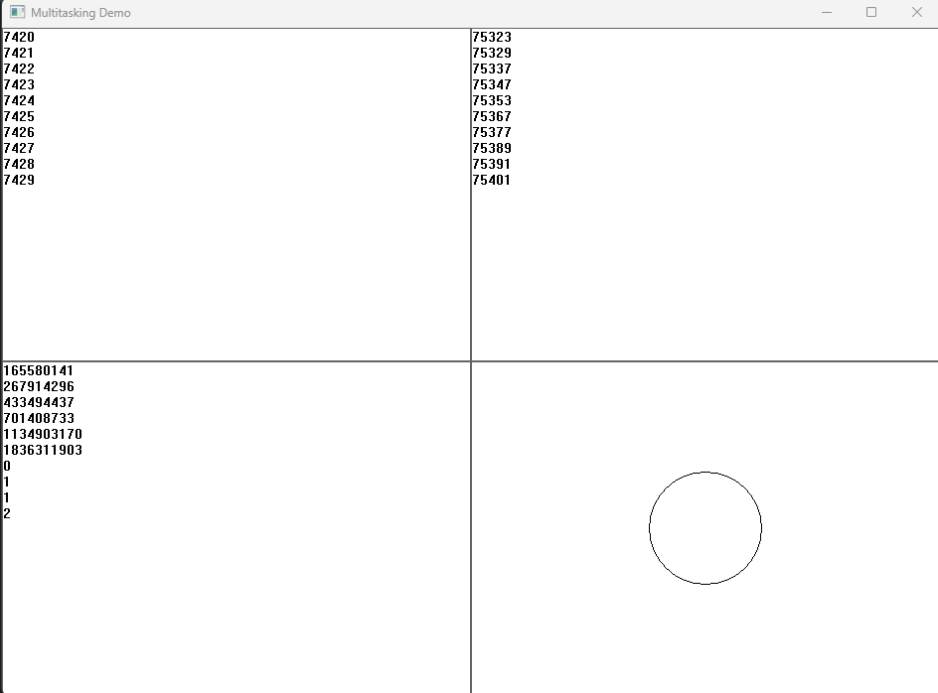

All the 4 subwindows above do different things.

In Conclusion:

While the MULTI1 program demonstrates a viable approach to simulating multitasking within a single-threaded Windows application, it's essential to consider its limitations and potential performance bottlenecks. For more demanding scenarios, exploring true multithreading or alternative strategies for handling window updates might be necessary to achieve optimal performance and responsiveness.

KEY DIFFERENCES BETWEEN MULTI2 AND MULTI1:

Multithreading Paradigm:

MULTI1 simulates multitasking within a single thread using timers and asynchronous window procedures.

MULTI2 embraces true multithreading, creating separate threads for each child window's tasks, enabling genuine concurrent execution and potentially better performance.

Update Mechanism:

MULTI1 relies on a timer to periodically trigger updates in child windows.

MULTI2 removes this timer dependency. Threads autonomously handle updates, potentially enhancing responsiveness and avoiding timer-related constraints.

Code Structure:

MULTI2's main window code is simplified as it no longer manages timers or sends WM_TIMER messages.

Thread functions encapsulate each child window's logic, promoting better code organization and maintainability.

Thread Communication:

MULTI2 introduces a PARAMS structure to facilitate communication between threads, containing window handles, dimensions, and a termination flag.

Additional Insights:

Performance Implications:

True multithreading in MULTI2 can often lead to better performance, especially on multiprocessor systems, as tasks can execute concurrently.

However, effective thread management and synchronization are crucial to avoid potential bottlenecks or race conditions.

Synchronization Considerations:

While MULTI2 doesn't demonstrate explicit synchronization mechanisms, more complex multithreaded scenarios often require them to ensure data consistency and prevent race conditions.

Error Handling:

Robust multithreaded applications should incorporate error handling within threads to gracefully manage unexpected issues and prevent application crashes.

Thread Priority:

MULTI2 doesn't explore thread priority settings, but adjusting priority levels can be useful in certain scenarios to prioritize critical tasks or prevent resource contention.

Design Trade-offs:

True multithreading can introduce complexity in terms of thread management, synchronization, and potential for race conditions.

Developers need to carefully assess the benefits and challenges of multithreading in the context of specific application requirements.

Alternative Approaches:

Beyond timers and multithreading, other techniques for handling concurrent tasks within Windows applications exist, such as message queues or asynchronous I/O, each with its own advantages and considerations.



Race Conditions:

Window Destruction: The bKill flag might not prevent a thread from attempting to access a destroyed window's device context if thread switching occurs at inopportune moments. While Windows 98 might handle this gracefully, it's not ideal to rely on such behavior.

Concurrent Drawing: Multiple threads drawing on the same window without synchronization could potentially lead to visual artifacts or inconsistencies. However, Windows 98 seems to serialize graphics calls, mitigating this issue.

GDI Object Handling: Windows 98 doesn't serialize access to GDI objects, so threads could inadvertently destroy objects being used by others. This requires careful synchronization or avoidance of object sharing.

Synchronization Needs:

Critical Sections: While MULTI2 doesn't use them, critical sections (using EnterCriticalSection and LeaveCriticalSection) are essential tools for protecting shared data and resources in multithreaded environments. They ensure that only one thread can access a critical section at a time, preventing race conditions.

Best Practices:

* Use critical sections to protect shared data structures and resources.
* Avoid sharing GDI objects between threads whenever possible.
* If GDI object sharing is unavoidable, implement proper synchronization mechanisms.

Key Takeaways:

* Multithreaded programming introduces complexity and potential for race conditions.
* Careful synchronization is crucial for ensuring data consistency and preventing unexpected behavior.
* Understanding operating system behavior and API thread safety is essential for robust multithreaded applications.
* Even when an operating system handles certain situations gracefully, it's best to implement explicit synchronization for clarity, maintainability, and portability across different environments.

UNDERSTANDING THE SLEEP FUNCTION'S ROLE IN MULTITHREADED WINDOWS PROGRAMMING:

Purposeful Pauses: The Sleep function serves as a strategic tool for temporarily halting a specific thread's execution within a multithreaded Windows application. This intentional pause enables developers to control the timing of tasks, create delays, and even implement basic animation effects, often within secondary threads.

Mechanism and Usage:

Voluntary Suspension: When a thread calls Sleep, it willingly suspends its own progress for a designated time interval specified in milliseconds.

Resource Management: During this sleep period, the thread relinquishes its processor time slices, refraining from consuming significant resources. However, it still necessitates minimal system attention for periodic checks to determine when to resume execution.

Yielding Time Slices: Passing an argument of 0 to Sleep causes the thread to forfeit any remaining time within its current time slice, allowing other threads to potentially gain priority.

Impact on Thread Concurrency:

Selective Suspension: Crucially, Sleep only affects the thread that directly invokes it. Other threads within the process, as well as those residing in separate processes, continue to operate undisturbed, maintaining overall system responsiveness.

Best Practices and Considerations:

Ideal for Secondary Threads:

Animation Without Windows: In scenarios where secondary threads lack windows, Sleep emerges as a viable technique for implementing simple animation sequences.

Pacing Background Tasks: It's often employed to regulate the pace of background tasks or lengthier jobs, ensuring they don't monopolize system resources.

Caution in Primary Threads:

Potential Responsiveness Issues: While Sleep can be utilized within primary threads, it's generally discouraged due to the risk of hindering message processing for windows, potentially compromising application responsiveness.

Alternatives for Primary Threads: In primary threads, timers or asynchronous operations often provide more suitable approaches for timing-related tasks.

Beyond Basic Timing:

* Synchronization for Complex Scenarios: While Sleep proves valuable for fundamental timing needs, more intricate multithreaded scenarios frequently necessitate sophisticated synchronization mechanisms.
* Exploring Alternatives: Developers should carefully consider alternatives like timers, events, and manual wait states using synchronization objects, depending on the specific requirements of their multithreaded applications and the interactions between threads.

In essence, Sleep offers a fundamental yet valuable tool for managing thread execution within multithreaded Windows programs. By understanding its purpose, usage, impact on concurrency, and best practices, developers can effectively leverage it to achieve desired timing behaviors and resource management, while ensuring overall application responsiveness.

RUSH HOUR AT THE MEMORY BANK: NAVIGATING THE CROSSROADS OF THREADS WITH TRAFFIC LIGHTS

Imagine bustling Times Square during rush hour, but instead of pedestrians, it's a throng of cars, all rushing to access the same bank at the intersection. This, my friend, is the world of multithreaded programming, where multiple threads, like those impatient drivers, want to access shared resources (think bank accounts) at the same time.

Without any order, it's pure chaos. Cars collide, accounts get mixed up, and the whole system grinds to a halt. This is exactly what happens in a multithreaded program without synchronization. Threads trying to update the same information simultaneously can lead to corrupted data, unexpected crashes, and buggy behavior.

Enter the critical section, the traffic light of the multithreaded world. It's a designated zone – a specific block of code – where only one car (thread) can enter at a time. Just like a crossing with flashing yellow arrows, the critical section uses synchronization mechanisms, like traffic cops or stop signs, to act as gatekeepers.

Here's how it works:

* Car Approaching: A car (thread) arrives at the critical section, like reaching the bank entrance.
* Requesting Entry: The driver (thread) signals the cop (synchronization mechanism), like waiting in line.
* Checking the Line: The cop (mechanism) checks if the bank counter is occupied, like looking for an open lane.
* Granting Access: If it's free, the car (thread) gets the green light and enters the critical section, like stepping into the bank.
* Exclusive Zone: While inside, the car (thread) has exclusive access to the counter (shared data), like safely withdrawing or depositing money.
* Exiting Gracefully: Once done, the driver (thread) leaves the bank (critical section), signaling the cop (mechanism) the lane is free.

This controlled access prevents race conditions, those moments where threads compete for the same data, potentially leading to errors. Imagine two cars trying to reach the same teller at once – chaos ensues!

By strategically placing traffic lights (critical sections) in your multithreaded program, you ensure smooth traffic flow, data integrity, and ultimately, a well-functioning system. You've transformed the frantic rush hour into a coordinated queue, where each thread gets its turn without the risk of a multi-car pileup.

Just like cars at an intersection, threads are independent paths of execution within a program. They can access shared resources like variables, files, or data structures. Without proper synchronization, race conditions can occur, leading to unpredictable and potentially disastrous outcomes.

Race conditions are like cars approaching the intersection simultaneously without any traffic rule in place. Both threads might try to modify the same resource at the same time, resulting in incorrect or corrupted data.

Synchronization mechanisms act as the traffic lights, ensuring controlled access to critical sections and preventing collisions. Here are some common approaches:



* Mutual exclusion: This guarantees that only one thread can access a critical section at a time. Imagine a stop sign or a single traffic light at the intersection, allowing one car to proceed at a time.
* Semaphores: These act like traffic lights with multiple lanes. A semaphore variable tracks the number of resources available (green lights) and the number of threads waiting (red lights).
* Mutex with condition variables: This allows threads to wait for specific conditions before entering a critical section. Think of it as a traffic light combined with a sensor that detects approaching cars, ensuring there's no waiting when the intersection is clear.

Choosing the right synchronization mechanism depends on various factors like the nature of the shared resources, the expected traffic (thread concurrency), and the desired behavior.

The analogy also highlights the importance of reliable synchronization mechanisms. Just like malfunctioning traffic lights can lead to chaos, bugs in synchronization code can cause serious problems in your program.

Ultimately, thread synchronization is about establishing order and ensuring predictable behavior in your multithreaded program. By employing the right strategies and understanding the potential dangers, you can create programs that run smoothly and avoid the traffic jams of data collisions.

CRITICAL SECTIONS: PROTECTING DATA INTEGRITY IN MULTITHREADED ENVIRONMENTS

In multithreaded operating systems, multiple threads of execution can run concurrently within a single program, sharing resources and working towards shared goals. However, this concurrency introduces challenges when multiple threads attempt to access and modify shared data simultaneously. To prevent data corruption and ensure program stability, we introduce the concept of critical sections.

Understanding the Need for Coordination:

* Single-Tasking Simplicity: In single-tasking environments, programs operate without interference, eliminating coordination concerns.
* Multitasking Challenges: Even in multitasking systems, issues can arise when multiple programs access shared resources like files. Operating systems offer mechanisms like shared file access and record locking to address these challenges.
* Multithreading Complexities: Multithreading within a single program significantly increases coordination needs. Threads often share data, and modifications by one thread might conflict with operations by others, potentially leading to data inconsistencies and program crashes.

Critical Sections: Enforcing Exclusive Access:

* Definition: A critical section is a block of code designed to execute atomically, meaning it must complete without interruption from other threads. This ensures data integrity and prevents race conditions.
* Mechanics: Synchronization mechanisms, analogous to traffic lights, govern access to critical sections. They ensure only one thread enters a critical section at a time, preventing conflicts and maintaining data consistency.

Common Synchronization Mechanisms:

* Mutual Exclusion (Mutexes): These act as binary locks, allowing only one thread to hold the lock and enter the critical section at a time.
* Semaphores: Semaphores generalize mutexes, enabling control over multiple resources or resource pools.
* Monitors: High-level constructs that encapsulate shared data and provide built-in synchronization mechanisms.

Importance of Correct Implementation:

* Reliable Synchronization: Just as malfunctioning traffic lights lead to chaos, bugs in synchronization code can cause serious program errors.
* Careful Design and Testing: Proper design and testing of critical sections and synchronization mechanisms are crucial for ensuring multithreaded program correctness and reliability.

In essence, critical sections act as safeguards for multithreaded programs, preventing data corruption and ensuring predictable behavior by enforcing exclusive access to shared data when necessary. By understanding their purpose and the associated synchronization mechanisms, developers can build robust and efficient multithreaded applications.

UNDERSTANDING CRITICAL SECTIONS IN-DEPTH:

Critical sections are synchronization mechanisms that enforce exclusive access to shared resources or code blocks by multiple threads within a process. This prevents race conditions and ensures data consistency.

Key Functions:

1. Initializing a Critical Section:

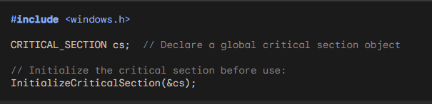

1. Entering a Critical Section:

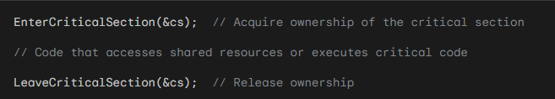

1. Deleting a Critical Section:

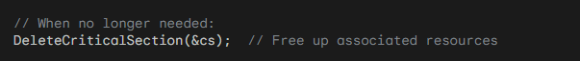

Important Considerations:

Opaque Structure: The CRITICAL_SECTION structure is internal to Windows, so don't modify its fields directly.

Ownership Semantics: Only one thread can "own" a critical section at a time. Other threads attempting to enter will be blocked until the owner releases it.

Blocking Behavior: EnterCriticalSection blocks the calling thread if another thread already owns the critical section.

Resource Management: Always initialize critical sections before use and delete them when no longer needed to release system resources.

Additional Notes:

* Initialization: Initialize critical sections only once, typically during program startup.
* Error Handling: Check the return values of these functions for potential errors.
* Alternatives: For more complex synchronization scenarios, consider mutexes, semaphores, or other synchronization primitives.

Best Practices:

* Use critical sections judiciously to protect specific critical sections of code or resources.
* Avoid overusing critical sections, as excessive synchronization can impact performance.
* Consider alternative synchronization mechanisms if critical sections don't meet specific requirements.

MUTUAL EXCLUSION AND CRITICAL SECTIONS:

Exclusive Access: Critical sections enforce mutual exclusion, meaning only one thread can execute within a critical section at a time. This prevents race conditions and ensures data consistency when multiple threads access shared resources or code.

Ownership Semantics: A thread "owns" a critical section when it enters it, blocking other threads attempting to enter until the owner exits.

Multiple Critical Sections:

Distinct Resources: You can define multiple critical sections to protect different shared resources or code blocks within a process. This allows for fine-grained control of thread synchronization.

Example: Four threads could use cs1 to synchronize access to one shared data structure and cs2 to synchronize access to a different structure.

Main Thread Considerations:

Potential Hangs: Be cautious when using critical sections in the main thread, as a secondary thread holding a critical section for too long could block the main thread's progress.

Optimized Access: Secondary threads might only need brief critical section access to copy shared data to local variables, minimizing blocking times.

Limitations and Mutexes:

Process Boundaries: Critical sections are limited to coordinating threads within a single process.

Cross-Process Synchronization: For coordinating threads across multiple processes, use mutex objects (mutual exclusion objects). These provide similar mutual exclusion guarantees but operate at the system level, allowing synchronization between threads in different processes.

Key Takeaways:

* Critical sections are essential tools for enforcing mutual exclusion in multithreaded Windows programs, ensuring data integrity and preventing race conditions.
* Understanding their ownership semantics, appropriate usage patterns, and limitations is crucial for effective multithreaded programming.
* For cross-process synchronization, mutex objects offer the necessary capabilities.

EVENT SIGNALING: ORCHESTRATING THREADS IN HARMONY

In the symphony of multithreaded programming, event signaling serves as the conductor, coordinating threads' interactions and ensuring harmonious execution. It empowers threads to communicate significant occurrences, such as task completion or the need for coordination.

Common Scenarios for Event Signaling:

* Task Completion Notification: A secondary thread signals its completion to the primary thread, allowing the latter to proceed with subsequent actions or initiate new tasks.
* Data Availability Signaling: A producer thread signals to a consumer thread that data is ready for processing, optimizing data flow and resource utilization.
* Error Signaling: Threads can signal error conditions to other threads, enabling error handling and corrective actions.
* Synchronization Signaling: Threads can use events to signal when shared resources become available or to coordinate access to critical sections, preventing data races and ensuring integrity.

Windows Event Objects: A Signaling Mechanism

* Creation and Management: Windows provides CreateEvent and CloseHandle functions to create and manage event objects.
* Signaling and Waiting States: Events can exist in signaled or non-signaled states.
* SetEvent: Signals the event, moving it to the signaled state.
* WaitForSingleObject or WaitForMultipleObjects: Allow a thread to wait for an event to become signaled.

Additional Considerations:

* Alternative Signaling Mechanisms: Semaphores, mutexes, condition variables, and even simple flags or shared variables can also facilitate inter-thread signaling, each with its own advantages and use cases.
* Synchronization and Data Integrity: Always employ appropriate synchronization mechanisms when threads access shared data to safeguard data consistency and prevent race conditions.
* Thread Termination Caution: While the TerminateThread function forcibly terminates a thread, its use is generally discouraged due to potential resource leaks and unpredictable behavior. Prefer cooperative thread termination methods whenever possible.

Awaiting BIGJOB1 Code for Deeper Exploration

To delve into the specifics of event signaling within the BIGJOB1 program, please provide its code for analysis. This will enable a thorough examination of its thread creation, signaling mechanisms, and potential abortion handling strategies.



Thread Creation and Management:

_beginthread: The program employs _beginthread to spawn the secondary thread responsible for the lengthy calculation.

Thread Function: The Thread function encapsulates the calculation logic and performs the following:

Initializes a loop counter and a timer.

Executes the "savage" benchmark calculation REP times, checking the bContinue flag within the loop to allow for potential abortion.

Upon completion or abortion, sends a custom message (WM_CALC_DONE or WM_CALC_ABORTED) to the main window using SendMessage.

Terminates using _endthread.

Window Procedure:

* Message Handling: The WndProc function handles various events and messages:
* Mouse Clicks: Initiates or aborts the calculation based on left and right mouse button clicks, respectively.
* Custom Messages: Processes completion or abortion messages from the secondary thread, updating status and triggering a window repaint.
* WM_PAINT: Displays status and results (or instructions) in the window's client area.
* Other Messages: Passes unhandled messages to the default window procedure.

User Experience:

* Status Messages: Clear status messages guide the user: "Ready," "Working," and "Done" (with elapsed time).
* Abortion Control: The user can directly abort a running calculation with a right mouse click.
* Error Beep: A beep signals an attempt to start a calculation while one is already in progress.

Synchronization Considerations:

* Potential for Race Conditions: While not explicitly shown in this simplified example, multithreaded programs often require careful synchronization to prevent race conditions, especially when multiple threads access shared data.
* Synchronization Mechanisms: Windows provides tools like critical sections, mutexes, events, and semaphores for thread synchronization.

Thread Safety:

* Volatile Keyword: The volatile keyword is used for pparams->bContinue to ensure correct memory access and visibility between threads, as this variable might be modified by the main thread while being read by the secondary thread.



Additional Explorations:

* Alternative Signaling Mechanisms: Explore using other synchronization mechanisms like events or semaphores for thread communication.
* Complex Calculations: Investigate performance implications of using threads for more computationally intensive tasks.
* Error Handling: Consider incorporating error handling to gracefully handle potential thread issues or calculation errors.

BIGJOB1's primary purpose is to demonstrate multithreading concepts, specifically:

Offloading Lengthy Tasks to Secondary Threads: It showcases how computationally intensive tasks can be assigned to separate threads to avoid blocking the main thread, thus maintaining program responsiveness.

Thread Communication and Signaling: It illustrates how threads can communicate with each other using custom Windows messages to signal completion or abortion of tasks.

User-Initiated Thread Control: It allows users to initiate and abort the calculation using mouse clicks, demonstrating a basic level of user interaction with threads.

Performance Considerations: It highlights the potential performance benefits of multithreading, though the specific calculation used (the "savage" benchmark) is somewhat artificial and might not fully reflect real-world scenarios.

While not directly applicable to practical tasks, it serves as an educational tool for:

Understanding Thread Creation and Behavior: It provides a concrete example of thread creation, execution, and communication.

Exploring Thread Synchronization: It serves as a starting point for understanding synchronization challenges and techniques in multithreaded programming.

Experimenting with Thread Management: It allows for experimentation with different thread management strategies, such as abortion and signaling.

Creating an Event Object:

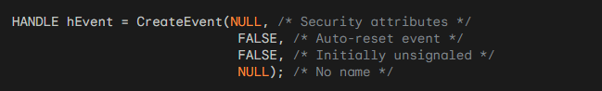

Signaling an Event:



Waiting for an Event (with a timeout):

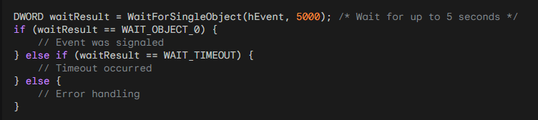

Resetting an Event (for manual-reset events):



Example of Thread Coordination using an Event:

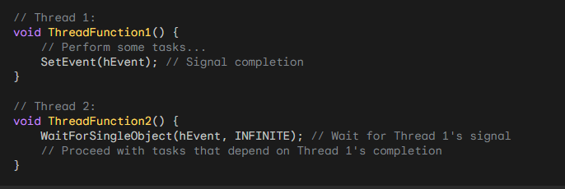

Remember that these are simplified examples. Actual multithreaded applications often involve more complex synchronization patterns and error handling.

Performance Considerations:

Benchmark Context: The "savage" benchmark is somewhat artificial and might not fully reflect real-world performance gains achievable with multithreading.

Complex Calculations: Further exploration of multithreading's impact on computationally intensive tasks is encouraged.

Additional Explorations:

Alternative Signaling Mechanisms: Investigate the use of events or semaphores for thread communication and synchronization.

Error Handling: Incorporate error handling to gracefully manage potential thread issues or calculation errors.

Complex Applications: Explore applying these concepts to more sophisticated multithreaded applications, addressing practical challenges and best practices.

EVENT OBJECTS AS THREAD SYNCHRONIZATION HUBS:

Binary State Machines: Event objects function as simple binary flags, existing in either a "signaled" (set) or "unsignaled" (reset) state. They serve as fundamental building blocks for thread coordination and synchronization in multithreaded applications.

Communication Channels: Threads can signal events to notify other threads of important occurrences, trigger specific actions, or coordinate access to shared resources.

Creating Event Objects:

CreateEvent Function: Event objects are created using the CreateEvent function, which offers a variety of configuration options:

* Security Attributes: Indicate whether the event can be shared between processes or is restricted to the current process.
* Reset Type: Determine whether the event is "manual-reset" (remains signaled until explicitly reset) or "automatic-reset" (unsignals automatically after a thread waits on it).
* Initial State: Specify whether the event starts in a signaled or unsignaled state.
* Event Name: Optionally assign a name to the event for identification and debugging purposes.

Signaling and Unsignaling:

Triggering Actions: Threads signal events using the SetEvent function, effectively setting the event's state to "signaled" and potentially waking up threads that are waiting on it.

Restoring Passivity: The ResetEvent function is used to set an event's state back to "unsignaled," typically for manual-reset events that require explicit clearance before being signaled again.

Waiting for Events:

Synchronizing Actions: Threads can wait for events to become signaled using the WaitForSingleObject function, allowing them to pause execution until a specific condition or action occurs in another thread.

Timeout Option: This function supports a timeout parameter, enabling threads to wait for a limited duration before proceeding, preventing indefinite blocking.

Automatic Reset Events:

Convenient State Management: Automatic-reset events simplify event management by automatically transitioning back to the unsignaled state after a single thread successfully waits on them. This eliminates the need for explicit calls to ResetEvent in many scenarios.

BIGJOB2 Integration:

Persistent Thread Model: BIGJOB2 demonstrates a programming model that leverages a persistent thread throughout the program's lifetime, utilizing an event object to activate the calculation only when necessary.

Event-Driven Efficiency: This approach can potentially improve responsiveness and resource utilization, as the thread idles until signaled, rather than being repeatedly created and destroyed for each calculation.

Code Analysis: While the specific code for BIGJOB2 is not provided, examining its implementation would reveal concrete examples of event object usage and how they integrate with other program components.

Additional Considerations:

Reset Type Selection: Carefully choose between manual-reset and automatic-reset events based on the specific synchronization patterns and thread interactions required in your application.

Synchronization Best Practices: Event objects are often used in conjunction with other synchronization mechanisms, such as critical sections or mutexes, to protect shared data and ensure thread safety in complex multithreaded scenarios.

Robust Error Handling: Incorporate proper error handling techniques when working with event objects to gracefully manage potential issues like timeouts or failure to signal, enhancing the overall resilience of your application.

PERSISTENT THREAD MODEL:

Highlighting Advantages: Emphasizes how a single, persistent thread throughout program execution can lead to:

* Reduced overhead compared to repeated thread creation and destruction.
* Enhanced responsiveness due to the thread's immediate availability.
* Potential for improved performance through better resource utilization.

Exploring Synchronization Implications: Discusses the importance of synchronization mechanisms (e.g., critical sections, mutexes) in more complex scenarios where multiple threads might access shared data, ensuring thread safety and preventing race conditions.

Event-Driven Architecture:

Diving Deeper into Event Handling: Elaborates on the role of event objects in coordinating thread actions:

* Details how the window procedure signals the event object to trigger calculations.
* Explains how the worker thread waits for events to become signaled, entering a suspended state when idle and resuming upon notification.

Considering Alternative Event Types: Introduces the concept of manual-reset events, which remain signaled until explicitly reset, and their potential use cases in different synchronization patterns.

User Interaction and Status Display:

User Experience Focus: Emphasizes the importance of user-friendly interaction and clear feedback:

* Outlines how left mouse clicks initiate calculations and right mouse clicks abort them.
* Describes the informative status messages displayed in the window, indicating program state and calculation time.

Design Considerations: Proposes potential UI enhancements, such as progress bars or visual indicators, to further improve user experience and provide real-time feedback during calculations.

Code Structure and Components:

Window Procedure Deep Dive: Provides a more granular breakdown of the WndProc function's responsibilities:

* Explains how it handles various window messages, including creation, mouse events, custom messages from the worker thread, and window painting.
* Describes the management of the event object, PARAMS structure, and thread communication.

Worker Thread Breakdown: Delves into the Thread function's logic:

* Details its infinite loop structure, waiting for events and performing calculations.
* Explains the use of the bContinue flag to control abortion.
* Clarifies the communication of completion or abortion messages back to the window procedure.

Key Takeaways and Further Exploration:

Reinforcing Efficient Thread Handling: Reiterates the benefits of BIGJOB2's persistent thread approach for resource efficiency and responsiveness.

Stressing Event-Driven Benefits: Emphasizes the versatility of event objects for coordinating thread actions and enabling responsiveness in event-driven applications.

Expanding Horizons: Encourages further exploration of:

* Advanced synchronization techniques for complex multithreaded scenarios.
* Robust error handling strategies to gracefully manage potential thread failures or signaling issues.
* Performance optimization techniques, including alternative synchronization mechanisms and thread scheduling adjustments.

THREAD LOCAL STORAGE

Allows for persistent storage that is unique to each thread within a multithreaded program.

Necessary when multiple threads need to access and modify data independently without affecting other threads. The key functions are:

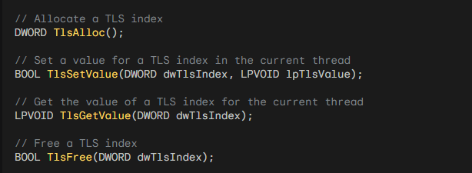

Steps for Using TLS:

Define a Data Structure: Define a data structure that represents the data you want to store in TLS. For example:

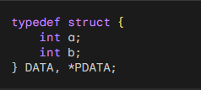

Allocate a TLS Index: Use the TlsAlloc function to allocate a TLS index. This index will be used to access the TLS data for each thread. Store the returned index in a DWORD variable. For example:



Set TLS Value in Each Thread: Before starting a thread, allocate memory for the TLS data using GlobalAlloc or any other memory allocation function. Cast the allocated memory to the data structure type and set it as the TLS value using the TlsSetValue function. For example:



Get TLS Value in Any Function: In any function where you need to access the TLS data, retrieve the TLS value using the TlsGetValue function and cast it to the data structure type. You can then access and use the data as needed. For example:

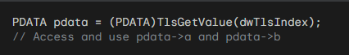

Free TLS Memory: When a thread finishes its execution, you should free the memory allocated for the TLS data using the appropriate memory deallocation function. You can retrieve the TLS value using TlsGetValue and then free the memory. For example:



Free TLS Index: When you no longer need the TLS index, use the TlsFree function to free it. This should be done after all threads have finished using TLS. For example:



Remember:

* TLS provides a mechanism for thread-specific data, ensuring data integrity and isolation in multithreaded environments.
* Use it for variables that need to maintain unique values for each thread throughout their execution.
* Properly allocate, set, get, and free TLS resources to avoid memory leaks and errors.

THREAD LOCAL STORAGE (TLS): ENABLING THREAD-SPECIFIC DATA IN MULTITHREADED ENVIRONMENTS

Understanding the Need for TLS:

* In multithreaded programs, multiple threads often share access to global variables and heap memory.
* However, scenarios arise where threads need to maintain unique copies of certain variables, ensuring data integrity and preventing conflicts.
* TLS addresses this challenge by providing a mechanism to store data that is specific to each thread, ensuring isolation and preventing unintended modifications by other threads.

Windows API Functions for TLS Management:

* TlsAlloc: Grants an unused TLS index, serving as a unique identifier for a thread-local variable.
* TlsSetValue: Associates a value (typically a pointer to a memory block) with a given TLS index for the current thread.
* TlsGetValue: Retrieves the value associated with a TLS index for the current thread.
* TlsFree: Releases a previously allocated TLS index.

Example Code:

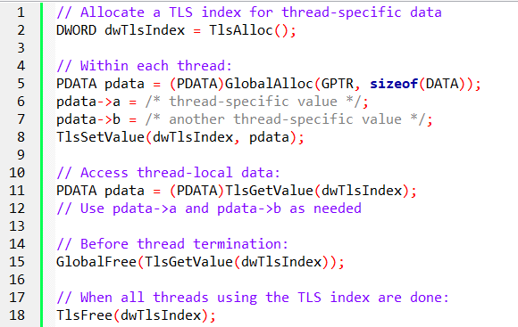

Microsoft C Extension: __declspec(thread)

Simplifies TLS usage by directly declaring thread-local variables:

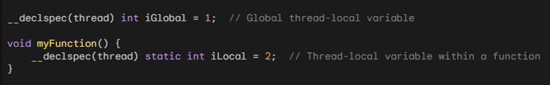

The __declspec(thread) extension in Microsoft C/C++ simplifies the usage of Thread Local Storage (TLS) by allowing you to directly declare thread-local variables. This extension is supported by the Microsoft C/C++ compiler and provides a convenient way to define thread-local variables without explicitly using the TLS API.

Here's how you can use the __declspec(thread) extension:

*Declare a Thread-Local Variable:*

To declare a thread-local variable, you can use the __declspec(thread) specifier before the variable declaration. For example:



In the above example, the variable `a` is declared as a thread-local variable. Each thread will have its own separate copy of `a`, and changes made to `a` in one thread will not affect its value in other threads.

*Use the Thread-Local Variable:*

You can use the thread-local variable a in the same way as any other variable. For example:

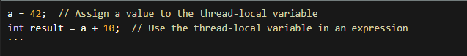

Each thread will have its own independent copy of `a`, and you can read from and write to `a` within each thread without worrying about thread synchronization or data interference.

It's worth noting that the `__declspec(thread)` extension can be used with various types of variables, including primitive types, structures, and pointers.

Benefits of __declspec(thread):

* Using the __declspec(thread) extension simplifies the usage of TLS by eliminating the need to explicitly allocate and manage TLS indices using the TLS API functions. It provides a more straightforward and concise syntax for declaring thread-local variables
* With __declspec(thread), the compiler takes care of allocating and managing the TLS storage for thread-local variables, making it easier to work with TLS in your code.

However, keep in mind that this extension is specific to the Microsoft C/C++ compiler and may not be portable across different compilers or platforms.

*Tell me more. How does the `__declspec(thread)` extension handle the initialization of thread-local variables? Are there any limitations or considerations when using the `__declspec(thread)` extension in Microsoft C/C++? Can you provide an example of how the `__declspec(thread)` extension can be used with structures or pointers?*

When it comes to the initialization of thread-local variables with the __declspec(thread) extension, each thread will have its own separate copy of the variable, and the initialization will occur automatically when a thread is created.

The initialization is performed once for each thread, ensuring that each thread starts with its own initialized copy of the variable. Here's an example to illustrate the initialization behavior of thread-local variables:

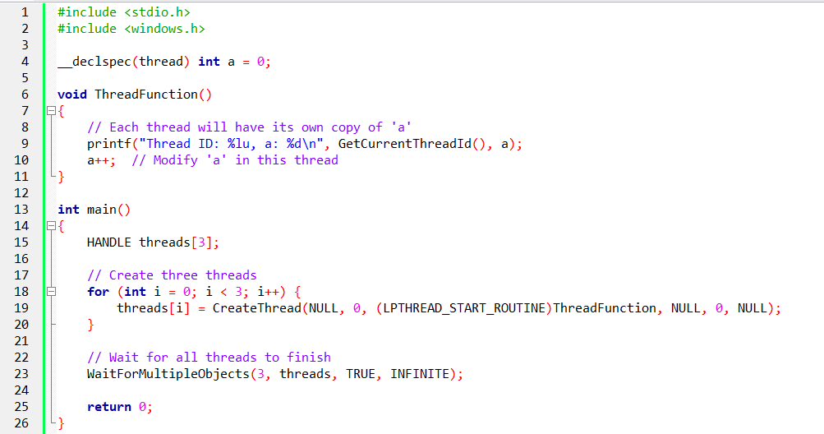

In this example, the a variable is declared as thread-local using __declspec(thread). Each thread will have its own copy of a, which is initialized to 0 automatically. The ThreadFunction is called from each thread, and they all access and modify their respective copies of a. The output will show that each thread has its own unique value of a.

Considerations and Limitations:

* The __declspec(thread) extension is specific to the Microsoft C/C++ compiler and may not be supported by other compilers or platforms. It is not part of the C/C++ language standard.
* Thread-local variables declared with __declspec(thread) are not suitable for inter-thread communication or synchronization. Each thread operates on its own independent copy of the variable, and changes made in one thread do not affect the copies in other threads.
* It's important to note that the initialization of thread-local variables with complex constructors or destructors is not supported with __declspec(thread). The initialization is limited to simple types or types with trivial constructors.

Example with Structures and Pointers:

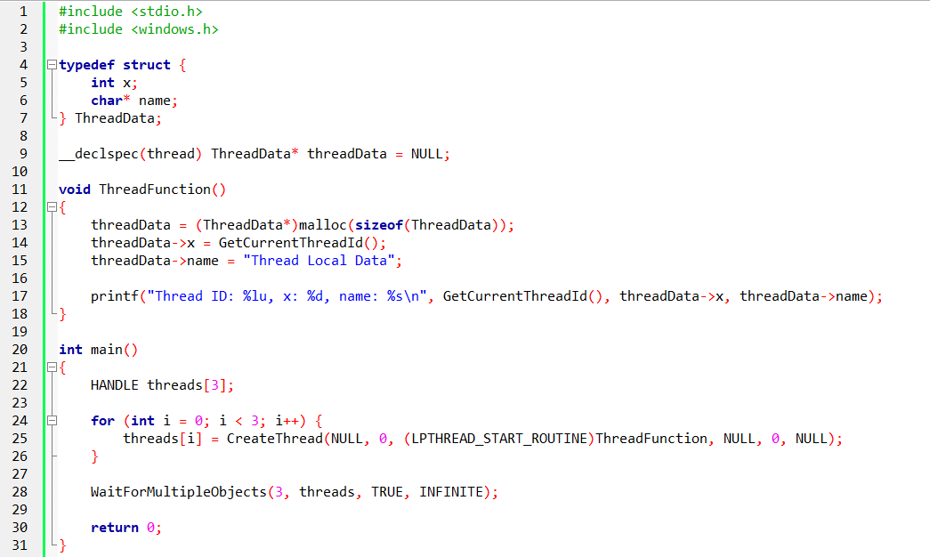

In this example, we declare a thread-local variable threadData of type ThreadData* (a pointer to a structure). Each thread will have its own separate copy of threadData. The ThreadFunction allocates memory for threadData and initializes its members. Each thread can access and modify its own copy of threadData.

*And that’s it for chapter 20 Multithreading…now to the final chapters.*